Steve Edwards's Reviews > Aboard the Democracy Train: A Journey Through Pakistan's Last Decade of Democracy
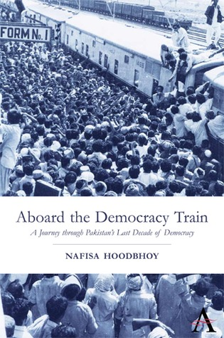
Top of Form
Want to Read
Bottom of Form
Top of Form
Bottom of Form
Rate this book
1 of 5 stars2 of 5 stars3 of 5 stars4 of 5 stars5 of 5 stars
Aboard the Democracy Train: A Journey Through Pakistan's Last Decade of Democracy
by Nafisa Hoodbhoy

Steve Edwards's review
Nov 26, 2017

liked it

Light on character development and providing few insights into the why? of deeply ingrained cultural traditions that superficially at least appear discriminatory, running contrary to values held dear by liberal "westernized" elites from democratic societies. Otherwise, for the outsider, an exposition of the defacto politics, current affairs and attitudes of a troubled region in the midst of fracticious change and shifting tribal and international allegiences, that resists the tendancy to sensationalise and benefits from the biographical viewpoint of the writer, who should be commended for her bravery, integrity and unwavering dedication to the journalistic profession as a cause for good.

